RETAIL BANKING ANALYSIS

An Industrial/Practical Training project report

Submitted to the Faculty of Engineering of

JAWAHARLAL NEHRU TECHNOLOGICAL UNIVERSITY

In partial fulfillment of the requirements for the award of Degree of

BACHELOR OF TECHNOLOGY

In

COMPUTER SCIENCE AND ENGENEERING

By

N.L. GAYATRI Y. MAYURI

(187Y1A0517) (187Y1A0525)

M.BHARGAVI N. KAVITHA

(187Y1A0567) (187Y1A0578)

J.SAMPATH(187Y1A0545) 

DEPARTMENT OF COMPUTER SCIENCE AND ENGENEERING

MARRI LAXMAN REDDY INSTITUTE OF TECHNOLOGY AND MANAGENENT

(Approved by AICTE-New Delhi, accredited by NACC with ‘A’ & Affiliated to JNTUH)

DEPARTMENT OF

COMPUTER SCIENCE AND ENGINEERING



CERTIFICATE

This is to certify that the Industrial/Practical Training Project Report entitled

“PATHOGENESIS OF LIVER CIRRHOSIS” is a bonafide record of work carried out by

N.KAVITHA, Y.MAYURI,N.L.GAYATRI,J.SAMPATH and M.BHARGAVI in partial fulfillment of the requirements for the degree of Bachelor of Technology in Computer science and Engineering of Jawaharlal Nehru Technological University Hyderabad, Hyderabad during the academic year 2019-2020.

RAMYA GUNTAMUKKALA

(Industrial/ Practical Training Coordinator)

ACKNOWLEDGEMENT

The satisfaction that accompanies the successful any task would be incomplete without the mention of people who made it possible and whose constant guidance and encouragements crown all the efforts with success.

We feel elated to express our floral gratitude and sincere thanks to ABDUL BASITH head of the department of Computer Science and Engineering for his encouragement all the way during analysis of the project. His annotations, insinuations and criticisms are the key behind the successful completion of the project work.

We would like to take this opportunity to thank our beloved principal Dr. Venkateshwara Reddy for providing a great support for us in completing our project and giving us the opportunity for doing the project.

We would like to take this opportunity to thank Smart Bridge educational services PVT(LTD) for providing this training program and support for us in completing our project.

Our special thanks to the faculty of our department and programmers of our computer lab. Finally, we thank our family members, non-teaching staff, attendants and our friends, who had directly or indirectly helped and supported us in completing our project in time.

TEAM MEMBERS

N. Kavitha(187Y1A0578)

Y. Mayuri(187Y1A0525)

N.L. Gayatri(187Y1A0517)

M. Bhargavi(187Y1A0567)

J. Sampath(187Y1A0545)

INDEX

TITLE

ABSTRACT

CHAPTER1: TITLE OF THE PROJECT

1.1: INTR0DUCTION

1.2: OBJECTIVES OF RESEARCH

1.3: PROBLEM STATEMENT

1.4 INDUSTRY PROFILE

CHAPTER2: REVIEW OF LITERATURE

CHAPTER3:DATA COLLECTION

CHAPTER4: METHODOLOGY

4.1 EXPLORATORY OF DATA ANALYSIS

4.2 FIGURES

4.3 DATA VISUALIZATION

4.4 DATA MODELLING

CHATER5: REFERENCES

CHAPTER6: CONCLUSION

ABSTRACT

Retail banking is widely recognized as an important factor for the development of a country. Retail banking helps the Indian banking industry by providing a wide range of innovative services. Retail loan is estimated to have accounted for nearly 1/5th of bank credit. Retail banking is when a bank executes transactions directly with consumers, rather than corporations or other banks. Services offered includes savings and transactional accounts, mortgages, personal loans, debit cards. This project attempts to highlight the prospects and the future role of retail banking in india. Retail banking is a very wide term that refers to dealings of commercial banks with individual costumers, both on liabilities and assets.

RETAIL BANKING ANALYSIS

INTRODUCTION:

Retail banking in which banking institutions execute transactions directly with customers Typical products: savings and transaction accounts, debit and credit cards, etc. The term is generally used to distinguish the banking services from investment banking, commercial banking or wholesale banking. It may also be used to refer to a division of a bank dealing with retail customers and also be termed as personal banking services. There are many subtypes of retail banking . They are

1.community development banks are regulated banks that provide financial services and credit undeserved markets or populations.

2.Private banks manage the assets of high-net-worth individuals.

3.Offshore banks are banks located in jurisdictions with low taxation and regulation. Many offshore banks are essential private banks.

3.Savings banks accept savings deposits.

Types of retail banking services offered by banks are:

1.Transactional accounts

2.Savings accounts

3.Debit cards, ATM cards, Credit cards

4.Travelers cheques

5.Mortgages

6.Home equity loans

OBJECTIVES OF RESEARCH

The main objective of retail banking analysis is to provide information about retail banking sector in India. Analysis of retail banking strategy provides current situation of the banking product and services. The objective of the study is to find out the gap that is existing between the perception and expectations of consumers of retail banking products and services and those of the entire bank employee in this perception. It is also proposed to study the consumer’s perceptional expectations regarding the product and services of the banks.

1.3 PROBLEM STATEMENT

Now-a-days in banking sector has lot of competition towards the product and services provided by the bank. So, customers have lots of choice to select the retail banking products. That’s why banks make a new strategy. Competition is so high between the bank’s products and services. Customers are satisfied with some bank products and services but some bank customers give negative feedback.

To solve these problems, we must use an algorithm. An algorithm is a step by step process to solve a problem. Here, we use KNN classification. KNN is flexible, easy to use ML algorithm. KNN gives a great

that it can be used both for regression and classification tasks. KNN is the supervised learning.

In KNN the prediction depends on features of nearest neighbors. In KNN we first use the number k of the neighbors. Then, we take the k nearest neighbors of new data point according to Euclidean distances.

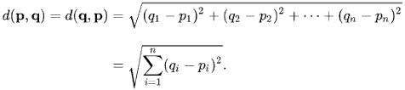

Among the k neighbors found the number of datapoints in each category. Now assign the new datapoint to the category where you counted the most neighbors. In this we use labelled (target variable) dataset to predict the class of new datapoint. The KNN algorithm is often used as a bench mark for more complex complication classifiers such as artificial neural network (ANN) or support vector machine (SVM).

ADVANTAGES:

* KNN algorithm is very simple and easy to understand and implement.
* KNN is a non-parametric algorithm which means there are assumptions to be met implement KNN.
* KNN doesn’t explicitly build any model, it is simple tags the new data entry based learning from historical data.
* KNN is a memory based approach the classification immediately adapts as we collect new training data. It allows the algorithm to respond quickly to changes i input during real time use.
* It is very easy to implement for multi class problem
* KNN can be used both for classification and regression.
* KNN algorithm gives the user to choose the distance while building KNN model. we can use Euclidean distance, hamming distance, minkowski distance.

Even though KNN has few disadvantages like it is a slow algorithm, it has no capability of dealing with missing values, but in this case KNN is one of the best algorithm to predict the values. The parameters used in KNN classifier are k-neighbors, metrics, p. The metric and p value are used to calculate the distance.

1.4 INDUSTRY PROFILE

There are a handful of definitions out there, but put simply, Machine Learning is the science of getting computers to execute

REINFORCEMENT LEARNING– Using this algorithm, the machine is trained to make specific decisions. The machine is exposed to an environment where it trains itself continually using trial and error. This machine learns from past experience and tries to capture the best possible knowledge to make accurate business decisions.

MACHINE LEARNING IS WIDELY APPLICABLE IN:

Most industries working with big data have recognized the value of Machine Learning technology. By collecting insights from this data, organizations are able to work more efficiently or gain an advantage over competitors.

Below are seven industries that are leveraging Machine Learning:

1.THE HEALTH CARE INDUSTRY:

Machine Learning is a fast-growing trend in the healthcare industry thanks to the advent of wearable devices and sensors that can use data to assess patient health in real time. In fact, as of 2017, 7.1 million Americans were enrolled in a digital health platform where vital signs are continually monitored by sensors worn on the body. This information is then sent to a Machine Learning analytics center that flags anomalies and alerts treatment professionals. The technology can also help medical experts analyze data to identify trends that may lead to improved diagnoses.

2.THE FINANCIAL SERVICES INDUSTRY:

Banks and other businesses in the financial industry use Machine Learning technology for two key purposes: to identify important insights in data, and to prevent fraud. The insights can identify investment opportunities, or help investors know when to trade. Data mining can also identify clients with high-risk profiles, or use cyber-surveillance to pinpoint warning signs of fraud.

3.THE RETAIL INDUSTRY:

Technologies powered by Machine Learning capture, analyze, and use data to personalize the shopping experience in real time. Algorithms discover similarities and differences in customer data to expedite and simplify segmentation for enhanced targeting. In fact, Machine Learning capabilities can present online shoppers with personalized product recommendations while adjusting pricing, coupons, and other incentives in real time.

4.THE AUTOMOTIVE INDUSTRY:

The automotive industry is taking steps to differentiate itself by leveraging Machine Learning capabilities and big data analytics to improve operations, marketing, and customer experience before, during, and after purchase. Predictive analytics lets manufacturers monitor and share vital information regarding potential vehicle or part failures with dealerships, reducing customer maintenance costs. And by identifying trends and patterns from large datasets on vehicle ownership, dealer networks can be optimized by location for accurate, real-time parts inventory and improved customer care.

5.THE GOVERNMENT AGENCIES:

Government agencies, such as public safety and utilities, have a particular need for Machine Learning since they have multiple sources of data that can be mined for insights. Analyzing sensor data, for example, identifies ways to increase efficiency and save money. Machine Learning can also help detect fraud and minimize identity theft.

6.TRANSPORTATION INDUSTRY:

The data analysis and modeling aspects of Machine Learning are important tools to delivery companies, public transportation, and other transportation organizations. In fact, analyzing data to identify patterns and trends is key to the transportation industry, which relies on making routes more efficient and predicting potential problems to increase profitability.

7.OIL AND GAS INDUSTRY:

Machine Learning has become an integral part of the operations of most oil and gas companies, allowing them to gather large volumes of information in real-time and translate data sets into actionable insights. They now need to view data as an extremely valuable resource, with huge upside for companies with innovative, robust Machine Learning strategies. Saving time, reducing costs, boosting efficiencies, and improving safety are all crucial outcomes that can be realized from using Machine Learning in oil and gas.

REVIEW OF LITERATURE

Reserve bank of India has prepared this “manual on financial and banking statistics “ on the recommendation of the steering committee set up by the Ministry of statistics and program implementation, government of India. The objective of this reference is to provide a methodological framework for compilation of statistical indicators, encompassing various sectors, monetary statistics etc., published by RBI. The manual is primarily devoted to the data compiled within the bank following an integrated and uniform approach. This document is to facilitate better understanding of conceptual issues on measurements of statistical indicators on the subject. Various departments of the bank and NABARD provided basic inputs for this manual. Secretarial support for compilation of this voluminous work was undertaken in the statistical analysis division, department of statistical analysis and computer services of the bank.

DATA MODELLING/PREDICTION

Several methods can be used to evaluate the performance of the model cross validation, confusion matrix, accuracy, precision and so on are some of the popular performance evaluation measures.

Some dataset contains irrelevant information, missing values and so on. These dataset should be handled properly to get a better result of the data mining process . Data preprocessing includes data cleaning, preparation, transformation and dimensionality reduction, which convert raw data into a form that is suitable for the preprocessing.

The major objective of the experiment is to show the effect of various preprocessing methods on the dataset prior to classification. Different classification algorithms were applied to compare the results.

4.METHODOLOGY

The methodology, depicted in the following figure, has been adopted for conducting retail banking analysis experiment.

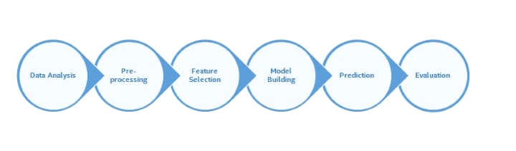

In this research, we have attempted to analyze and identify the influential factors on the customers switching intention in retail banking industry. For these purposes, used a combining qualitative and quantitative research approach, with a descriptive methodology and the data collecting method has been survey.

EXPLORATORY DATA ANALYSIS:

Exploratory Data Analysis is about applying techniques on data to gain insights before applying any formal modelling techniques. EDA describes data by means of statistical and visualization techniques. It brings out important aspects of the data.

By performing EDA on data, we look at the data from different angles and gain insights without assumptions – insights that can never be gained by just looking or glancing at a large dataset. We unearth what the data is or know if it is really what it is claimed to be. You never know what you can get from the data, or how critical and crucial insights can be in addressing a business problem.

Exploratory data analysis refers to the critical process of performing initial investigations on data so as to discover patterns, with the help of summary statistics and graphical representations. It is a good practice to understand the data first and try to gather as many insights from it. Exploratory data analysis is all about sense of data in hand. Exploratory data analysis is an approach to analyze the data sets, to summarize their main characteristics, often with visual methods.

Primarily exploratory data analysis is for seeing what the data set can tell us beyond the formal modelling. There are number of tools that are useful for Exploratory data analysis, but exploratory data analysis is characterized more by the attitude taken by particular techniques.

Typical graphical techniques in exploratory data analysis are:

1. Scatter plot
2. Histogram

FIGURES/DATAVISUALIZATION 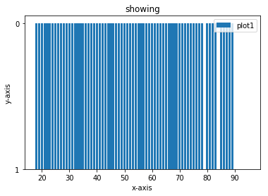

CAMPAIGN VS DEPOSIT

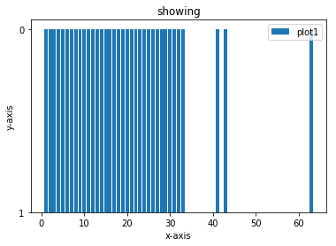

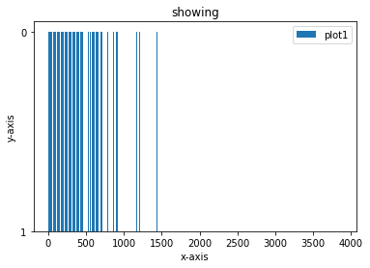 AGE VS DEPOSIT

DURATION VS DEPOSIT

REFERENCES:

1.DR.K.M. Bhattacharya &O.P. Agrawal, “Basics of Banking and Finance, Himalaya Publishing House.

2.https://www.bis.org/review/r050531f.pdf

3.http://www.theinternationaljournal.org/ojs

4.Reeta Mathur , “Recent Trends in Indian Economics”

5.A.S. Chawla, “Nationalization and Growth of Indian Banking”

6.http://kaggle.org

7.http://www.ijdnsonline.com

CONCLUSION:

There is a constant innovation in retail banking Banks now need retail as a growth trigger. This requires product development and differentiation, initial and business process reengineering, marketing, product pricing, customization etc. While retail banking offers phenomenal opportunities for growth the challenges are equally haunting how far the retail banking is able to lead growth of banking industry in future would depend on capacity building of the banks to meet the challenges and make use of opportunities profitably.